Chapter 11 Testing
Github site link – https://jocooper317.github.io/SDEV153-WebPage/
https://github.com/jocooper317/SDEV153-WebPage.git
W3C CSS Validation –
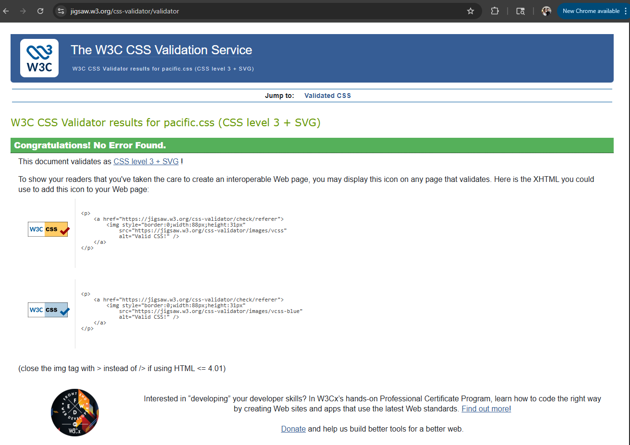
Yurts.html W3C Html validation –
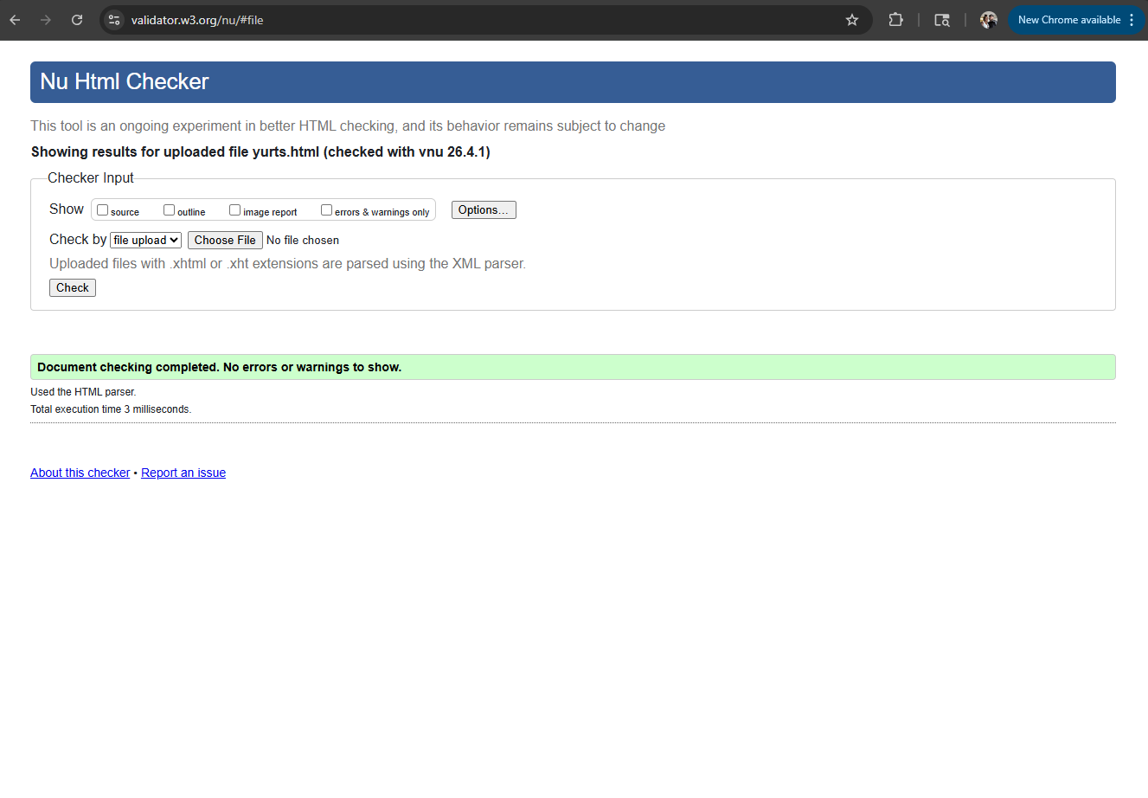
Yurts.html testing
Large view –

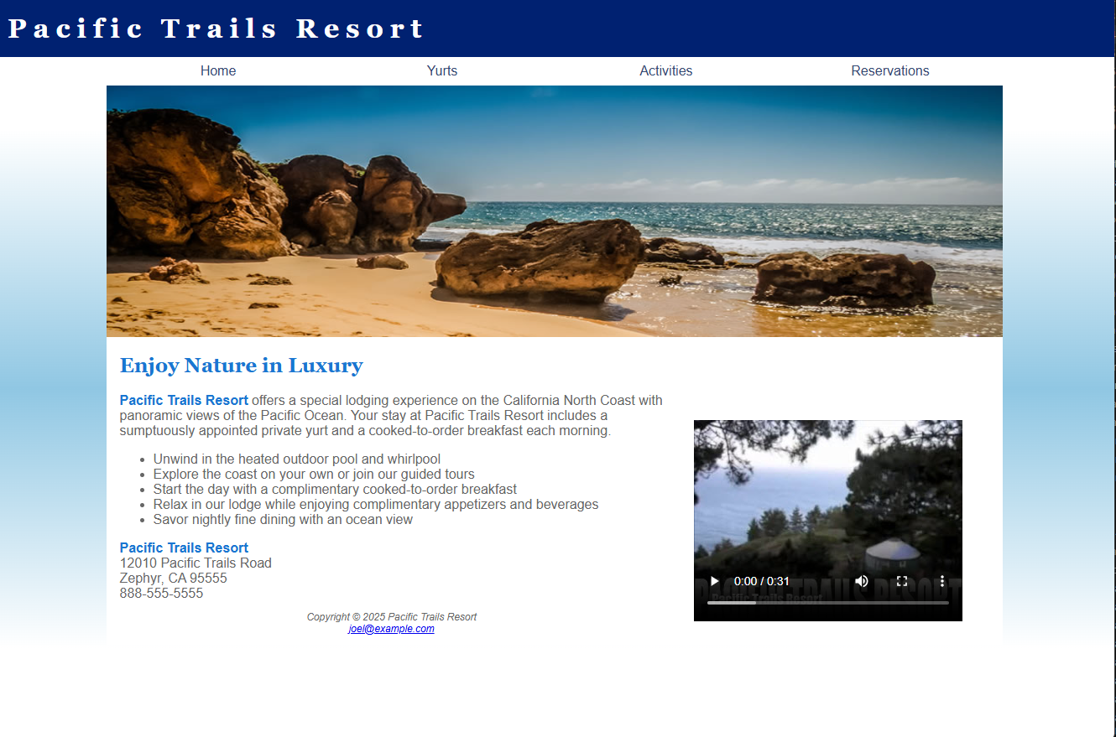
Medium View
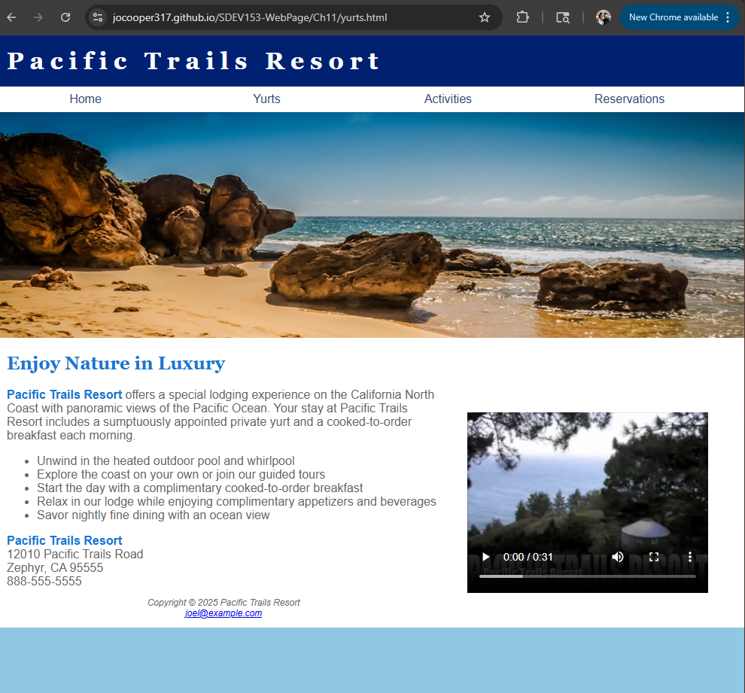
Small View –
Original from following the book –
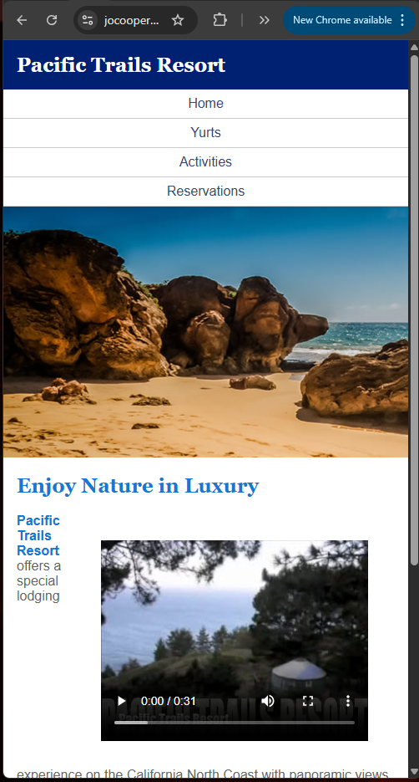
I changed the code a bit in the CSS to make it so that it would not push the text over to be so small and break the paragraph. So the below is the after of adding the additional changes so that the video will sit first and then the text will be below it.
